It was 25th November 2012, first time I came to know about Palle Srujana and China Sodhayatra through Eeandu Sunday magazine article. Almost 7 years I tried my level best to participate in China Sodhayatra but not possible due to my personal reasons. This time I strongly resolved to attend the yatra and finally got succeed to participate in 30th China Sodhayatra.
It is a wonderful experience which could not be expressed in words. Pivotal kingpin of Pallesrujana, Brigadiar Ganesham garu is the guiding source as well as true spirit for this yatra. I learned so many first timers in my life, like Working of weaving machine , using fishbone in weaving process, Gobar gas through cattle dung , Clay bricks making method, Goat rearing by villagers, etc.
I am very much pleased with the extemporic knowledge of various subject contents by Ganesham garu and Anjireddy garu.
Out of 25 participants, almost 90 percent are youth.Participation of youth in these kind of yatras is highly appreciable. Interacting with the villagers is heart touching and really they are great and wonderful.
Intoto, understanding and experiencing the four pillars of the yatra (Nature, Villagers, Co-Yatris & Self) is amazing.
Unfortunately, I have not maintained the daily record of events in this yatra. But all these memories are revolving continuously in my mind and I am eagerly waiting to participate in the next China Sodha Yatra.

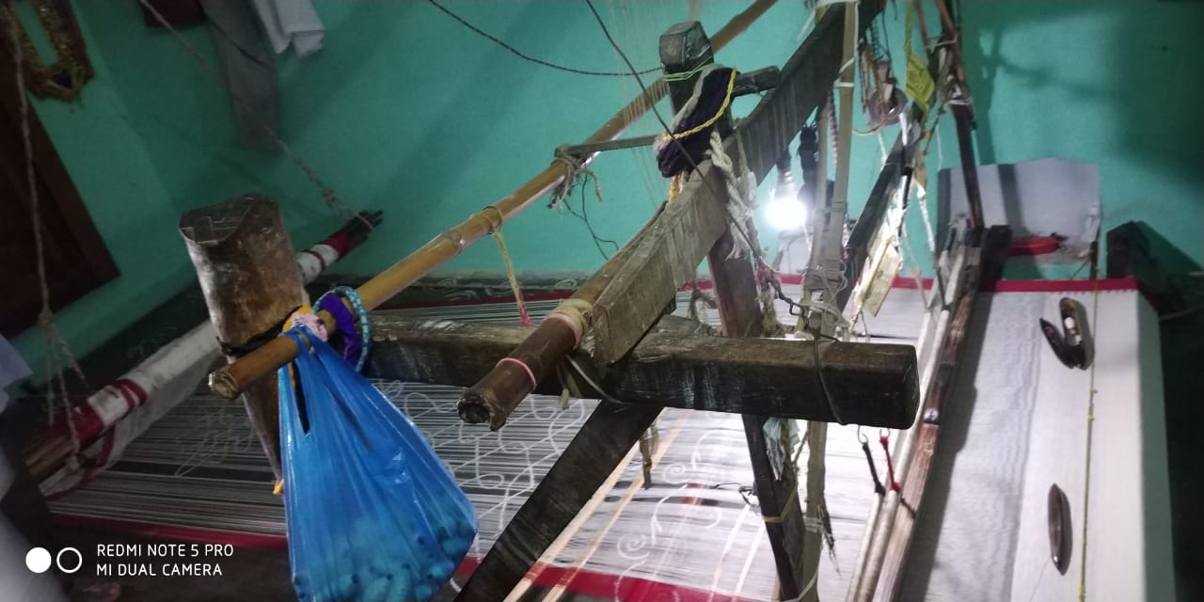
Weaving machine at Ponduru

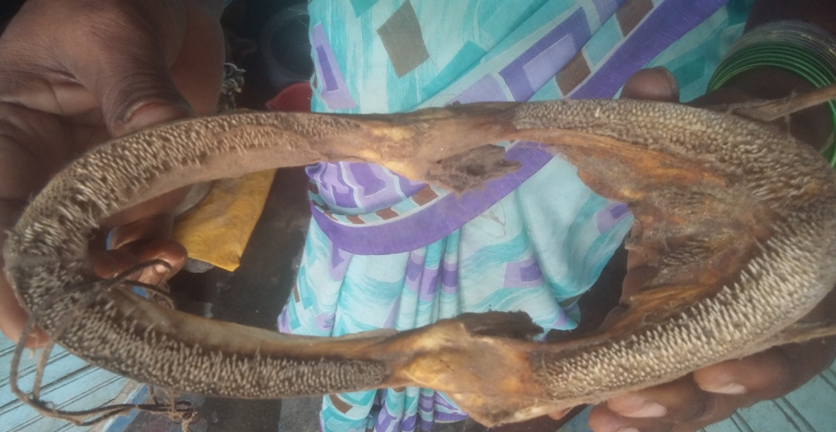
Fishbone using in weaving process at Ponduru Khadi

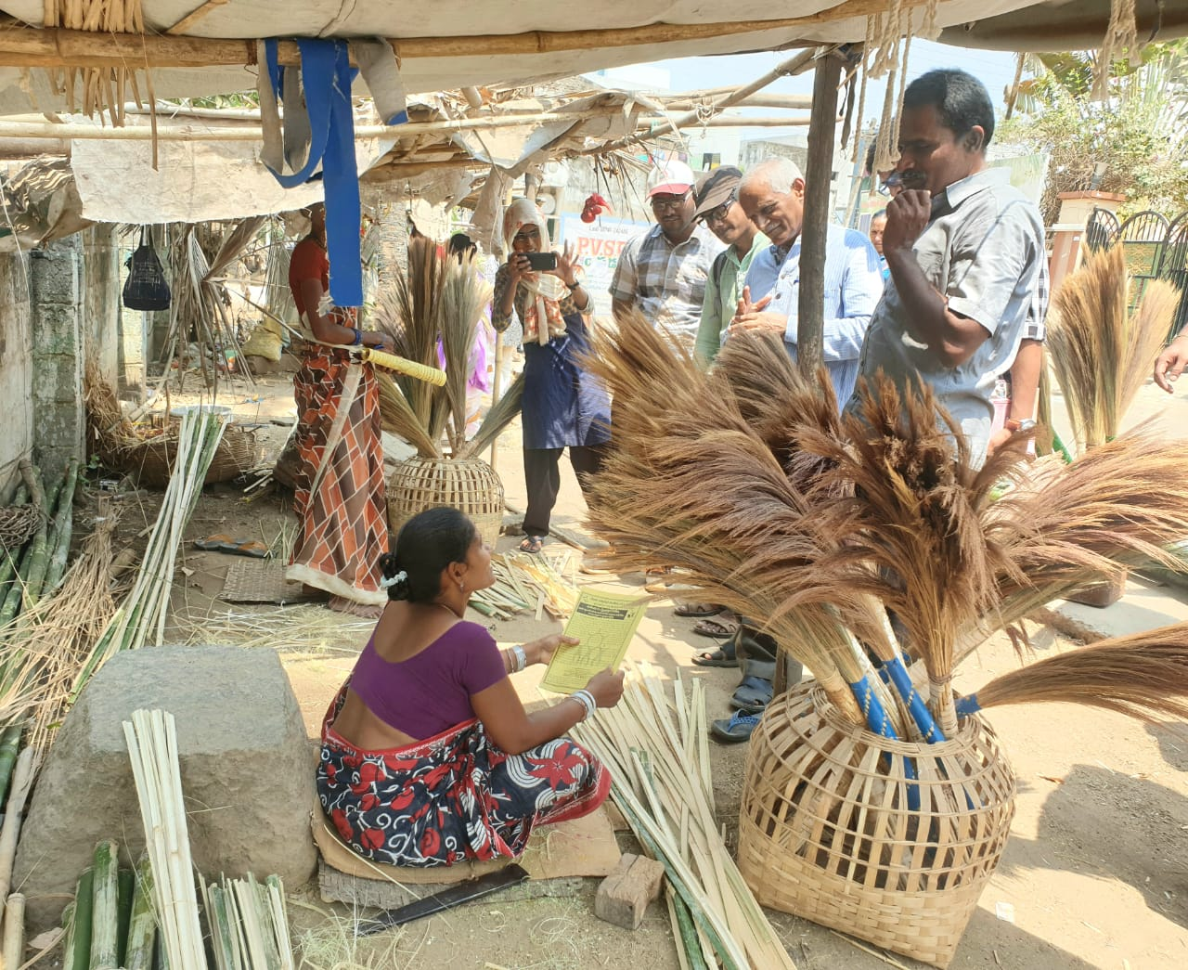
Interacting with broom seller in Ponduru

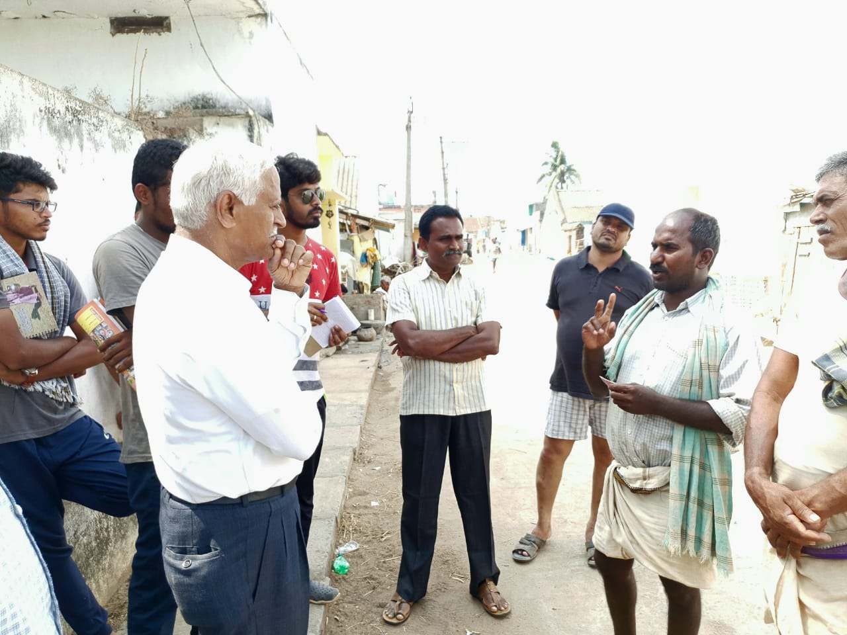
Listening to a farmer
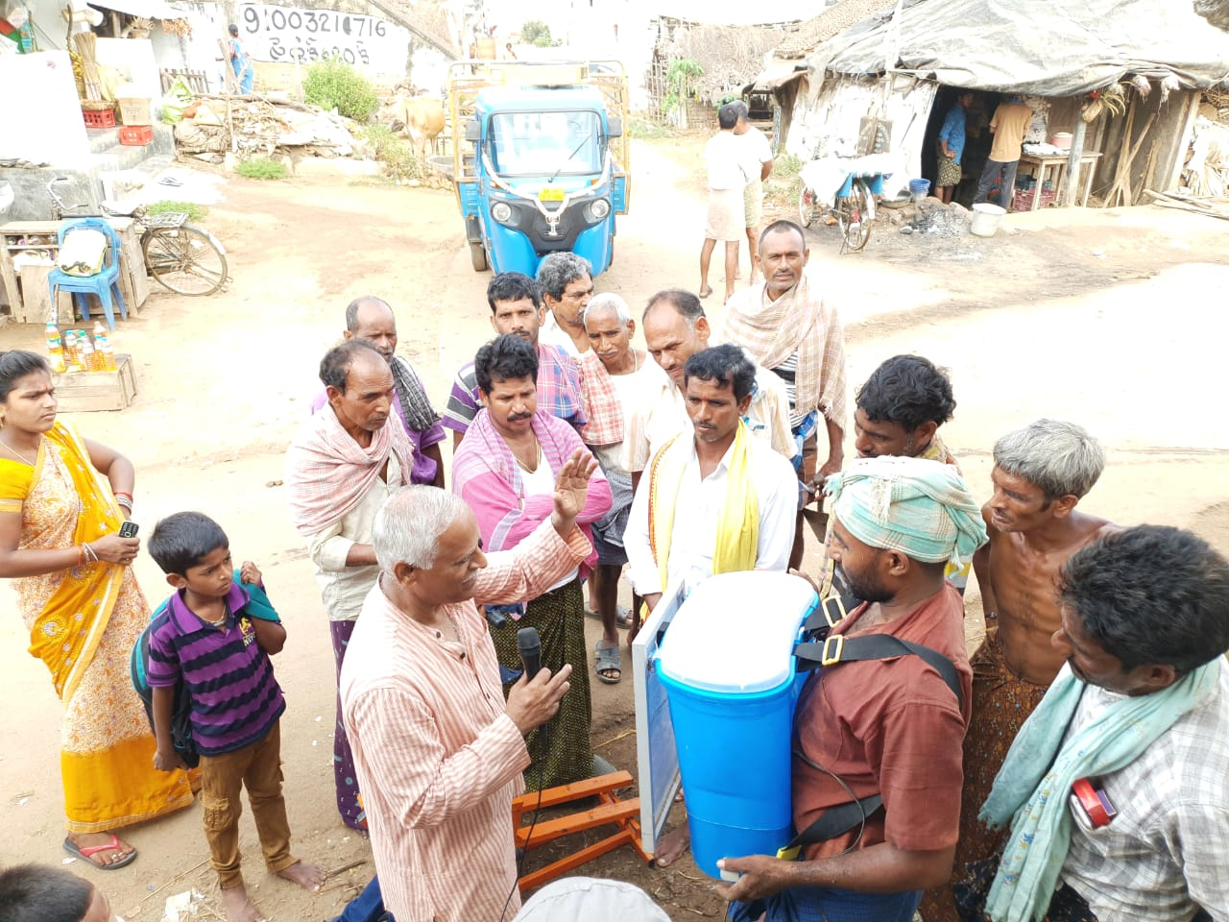
Explaining the working of gross root innovation product to villagers of Gorinta

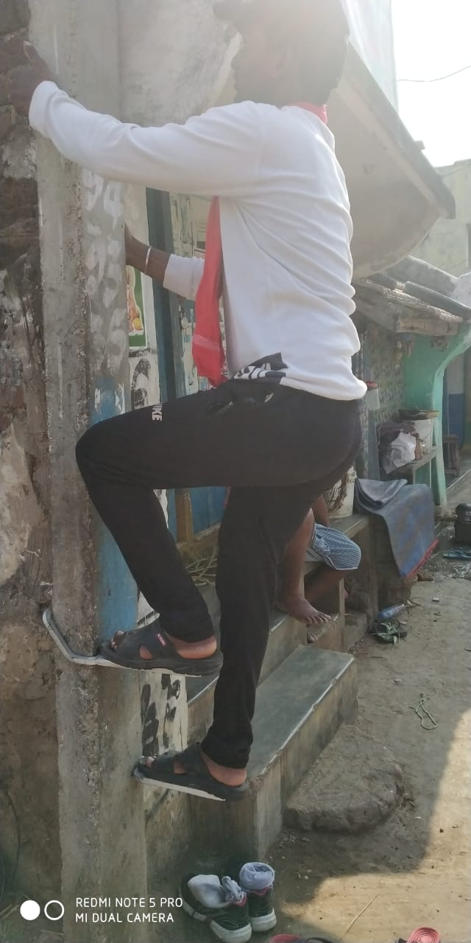
Demonstrating the working of pole climber by co-yatri
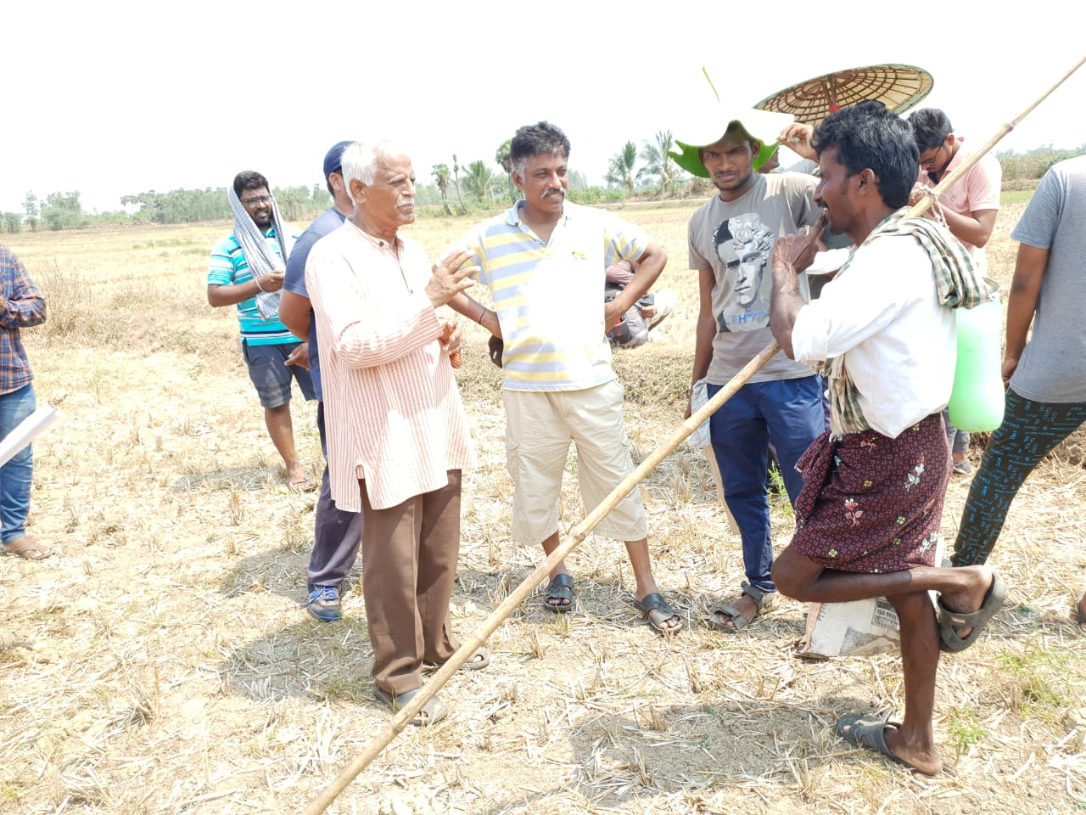
Enquiring information about rearing of goats in the fields

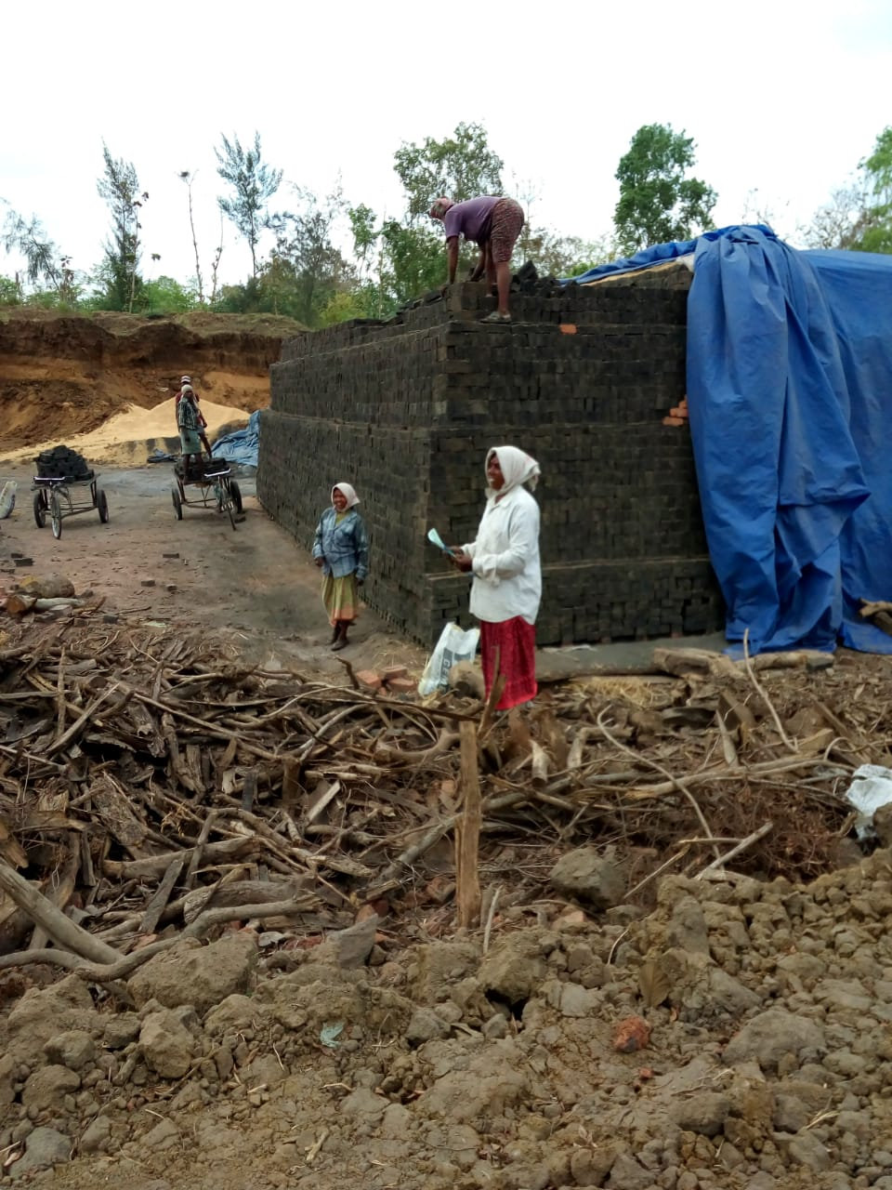
Clay brick making area in a village
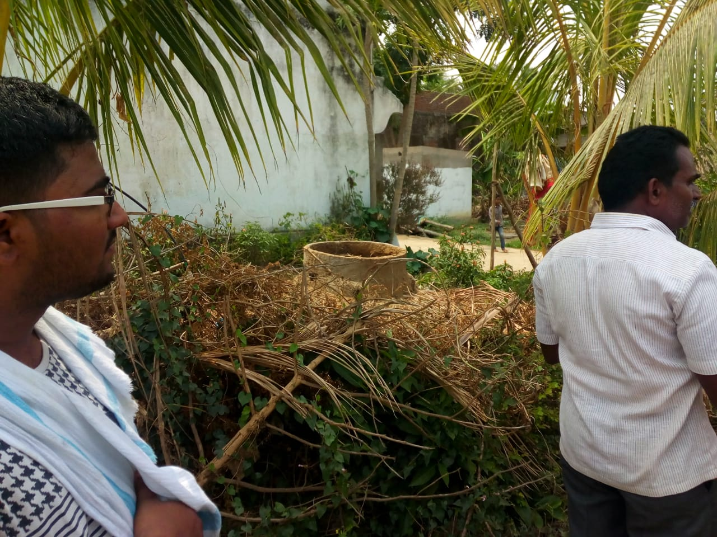
Gobar gas storage pit of cattle dung

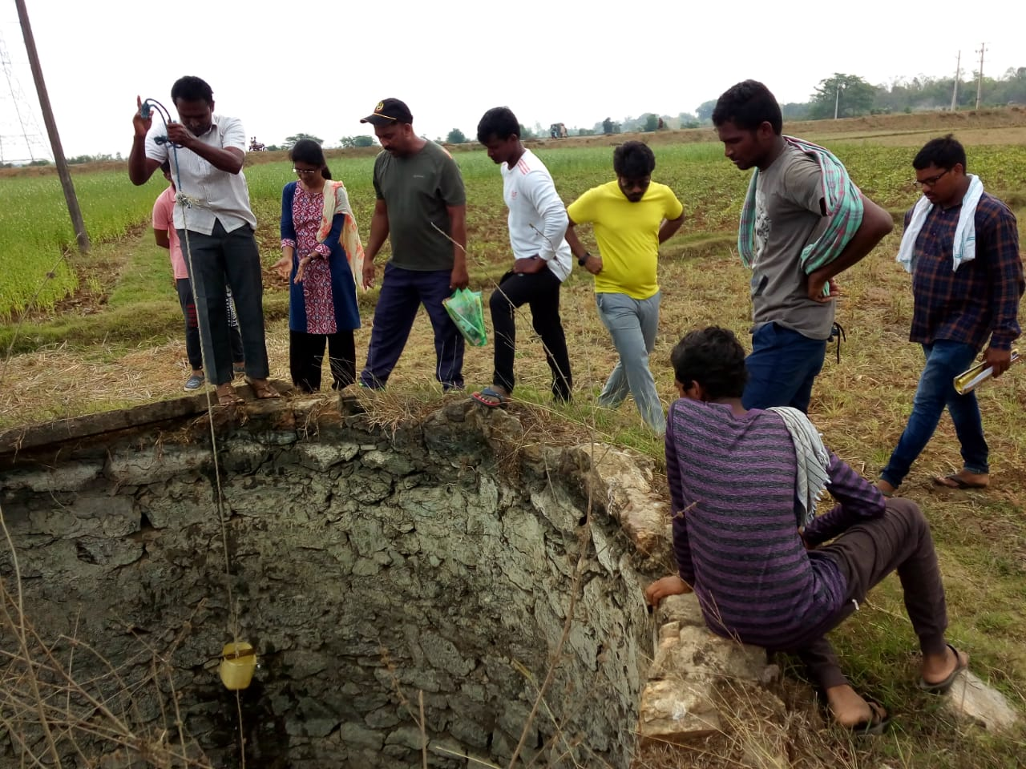
Angireddy garu explaining the salinity of drinking water in village well
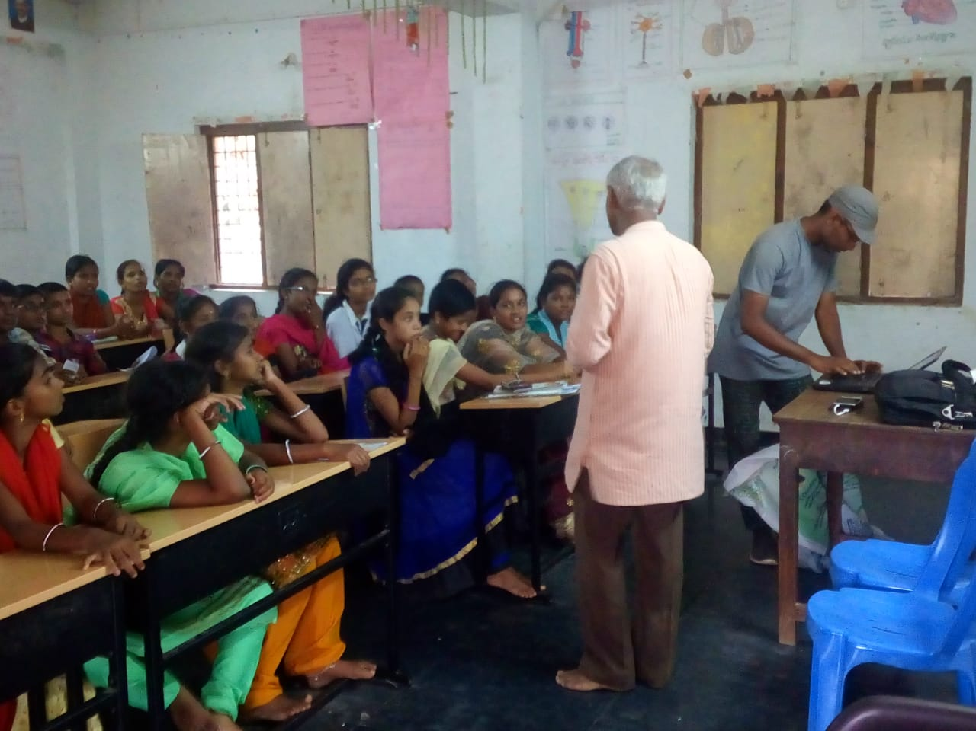
session taken by Sir to school children

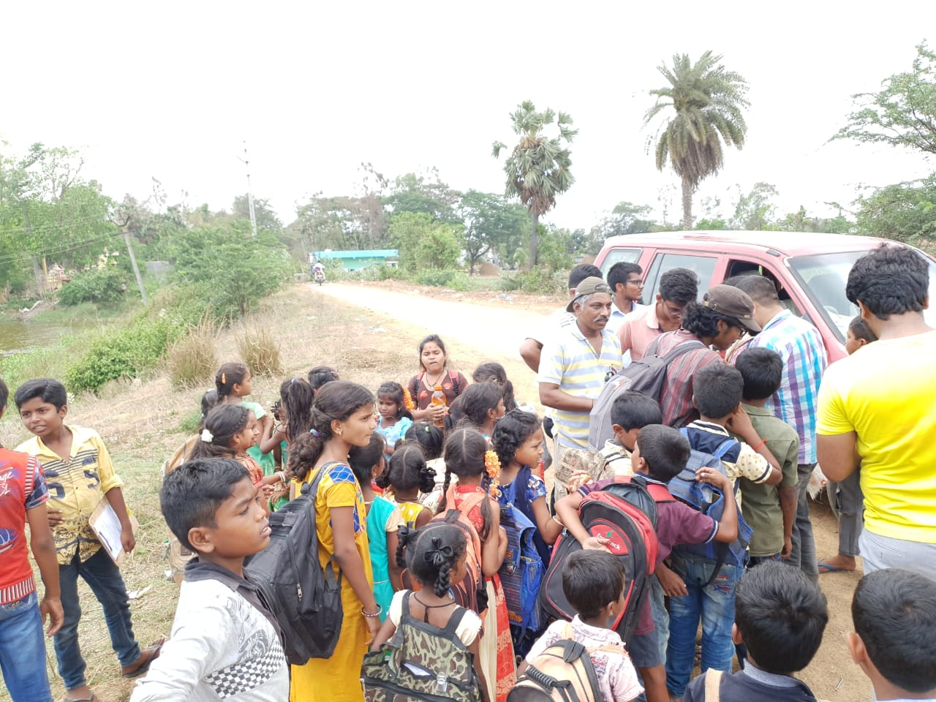
Distributing books,pens & pencils to school children in a village
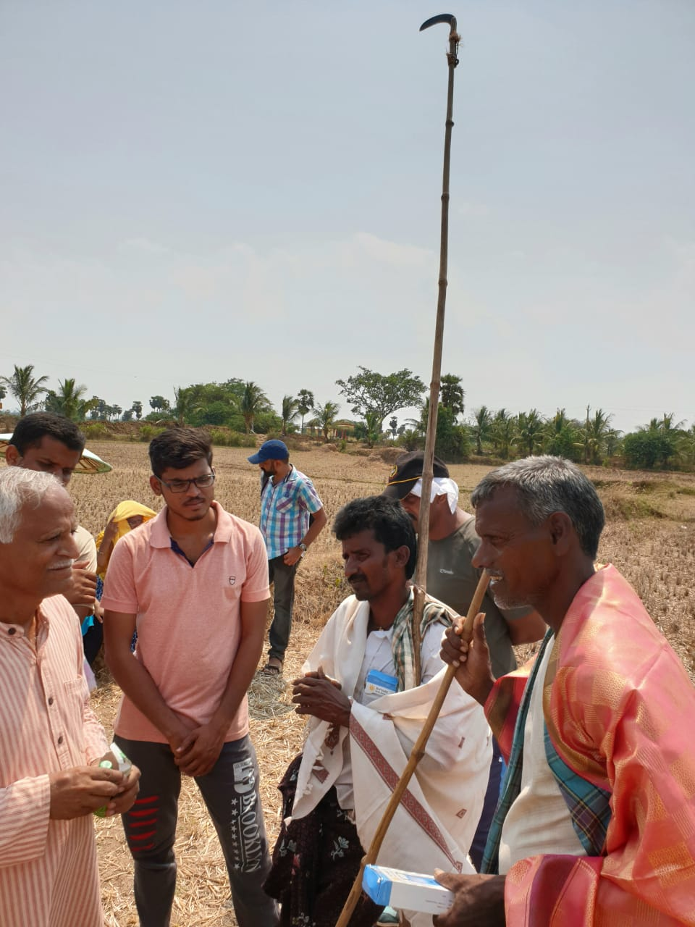
Felicitating goat rearers in a village field

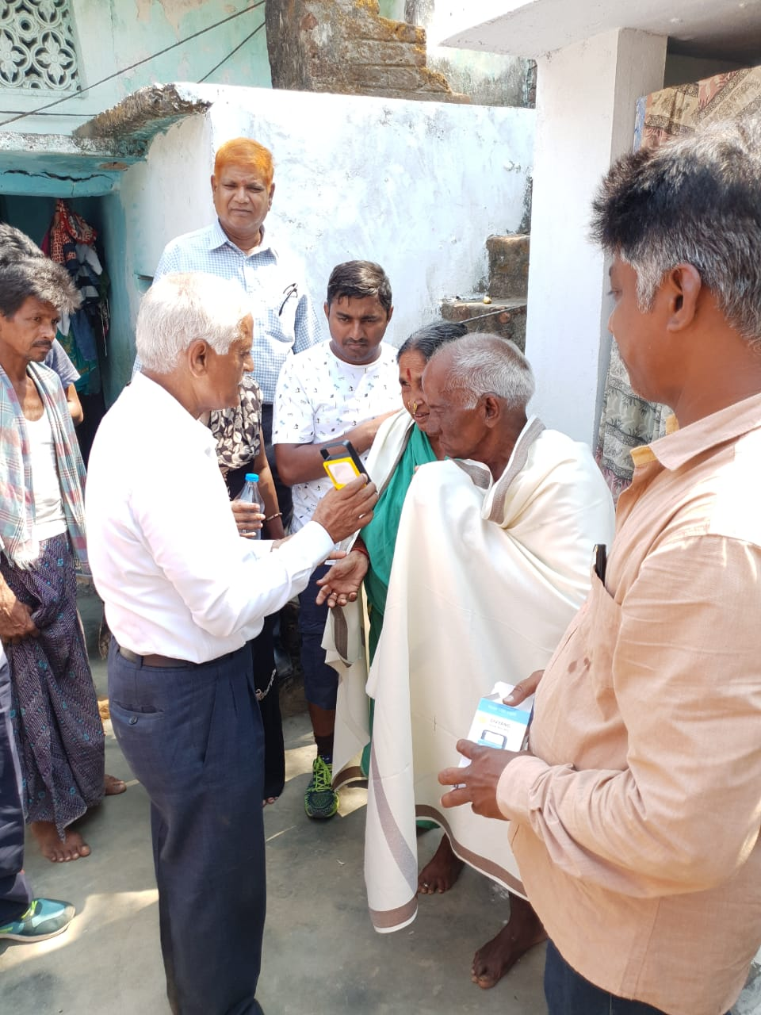
Felicitating old couple in the village
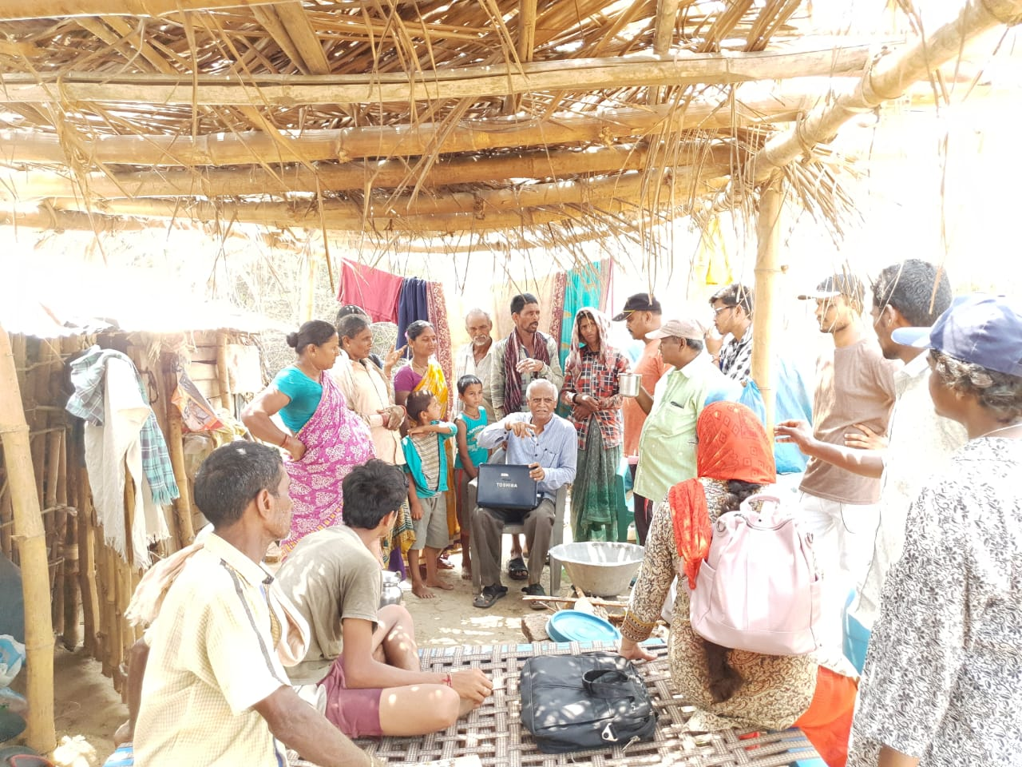
Interaction with villagers by Ganesham garu

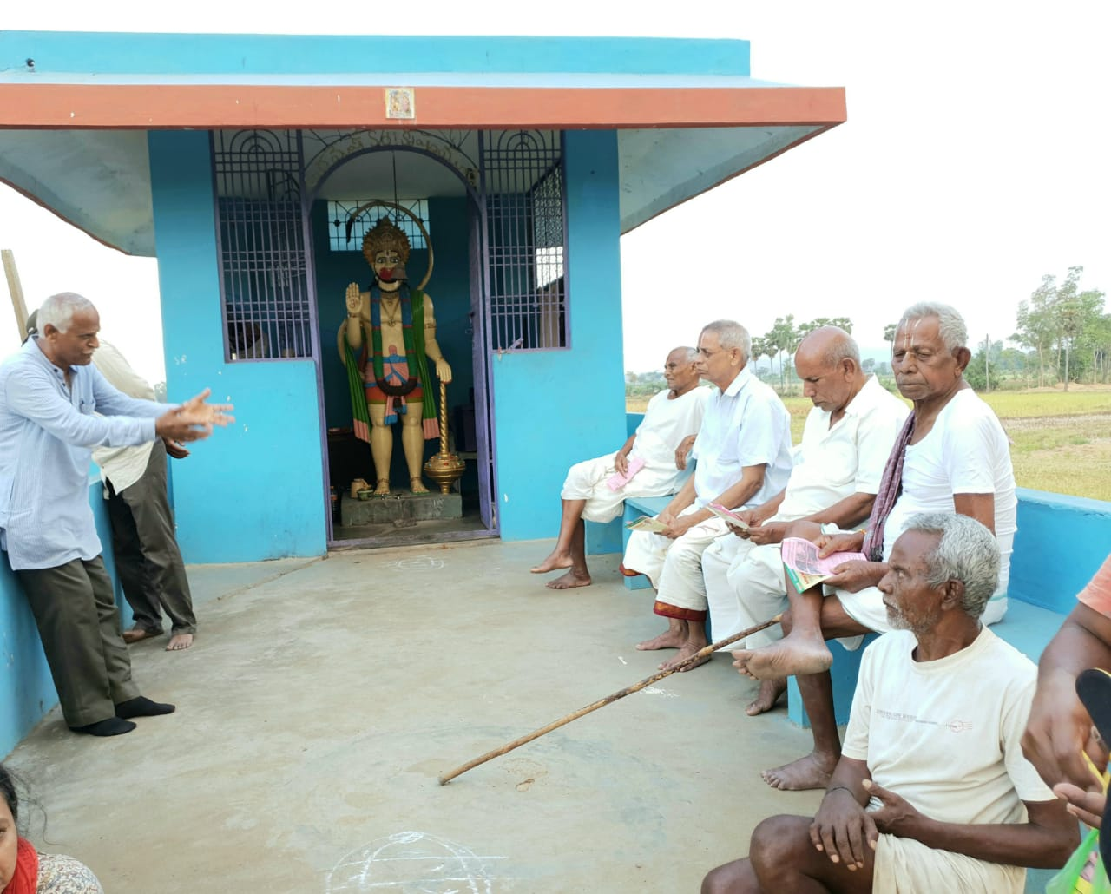
Discussing with village heads

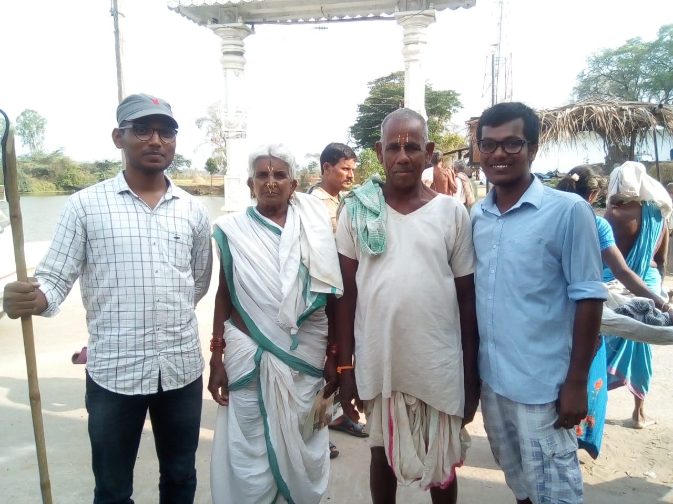
Co-Yatris with old age couple in a village

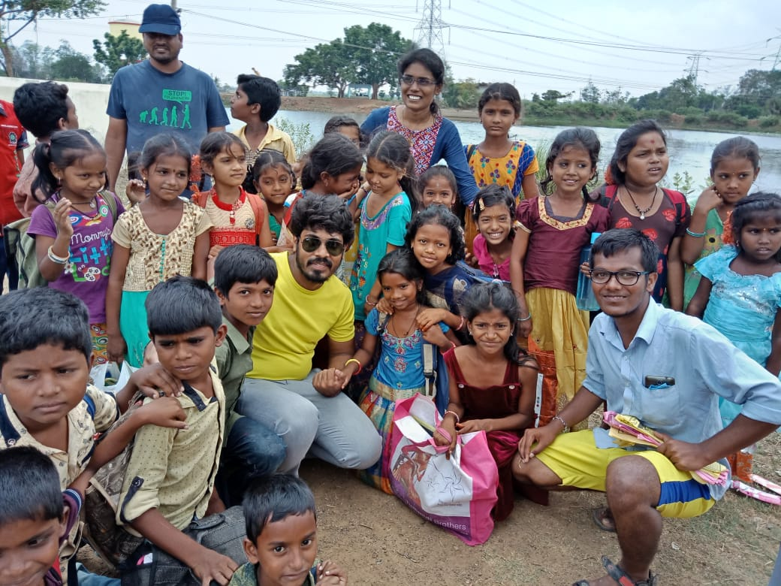
Co-Yatris with school children in a village
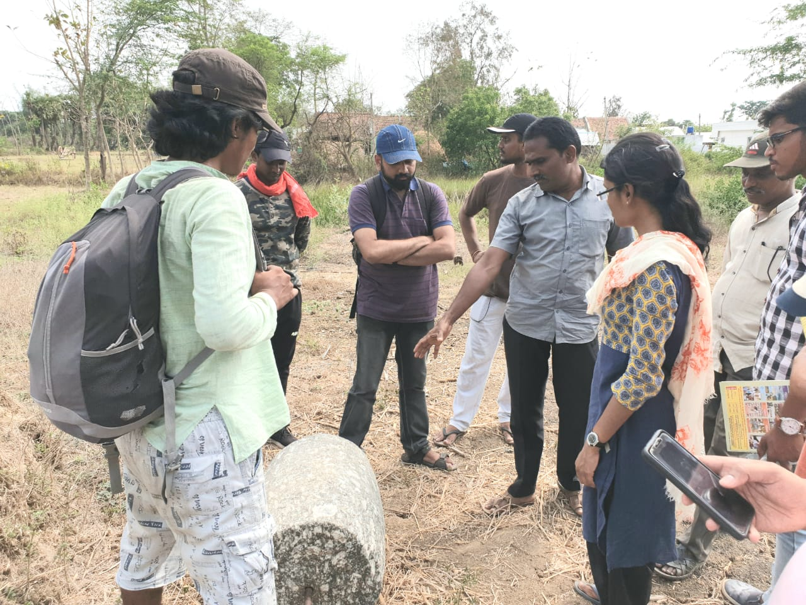
Clearing the doubts by Angireddy garu to sodhayatris

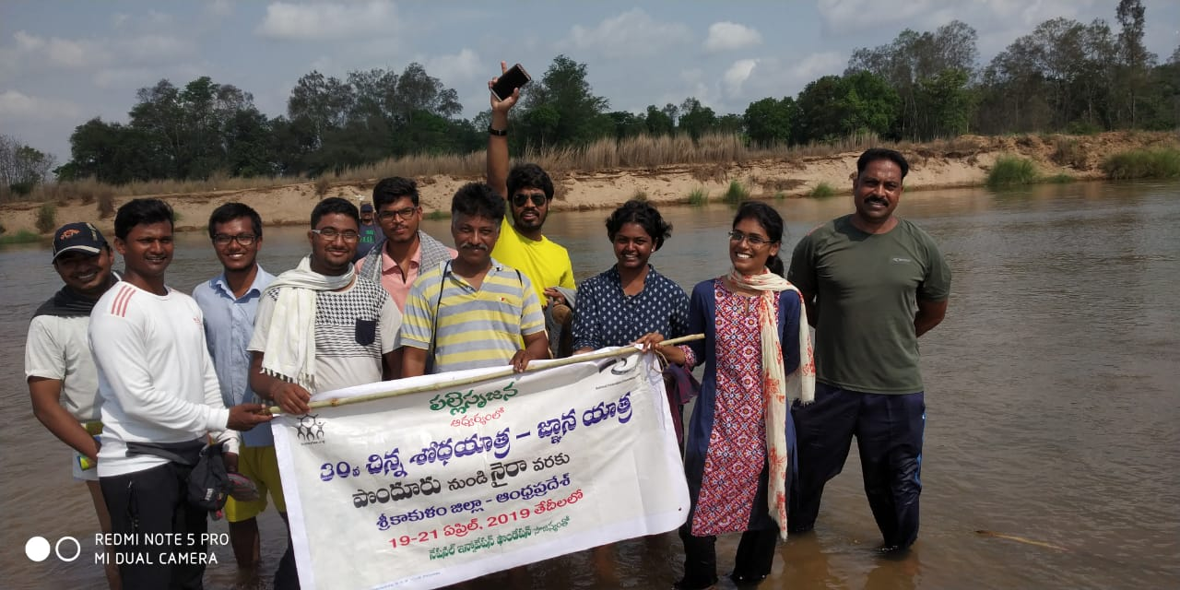
In the middle of Vamsadhara river with co-yatris

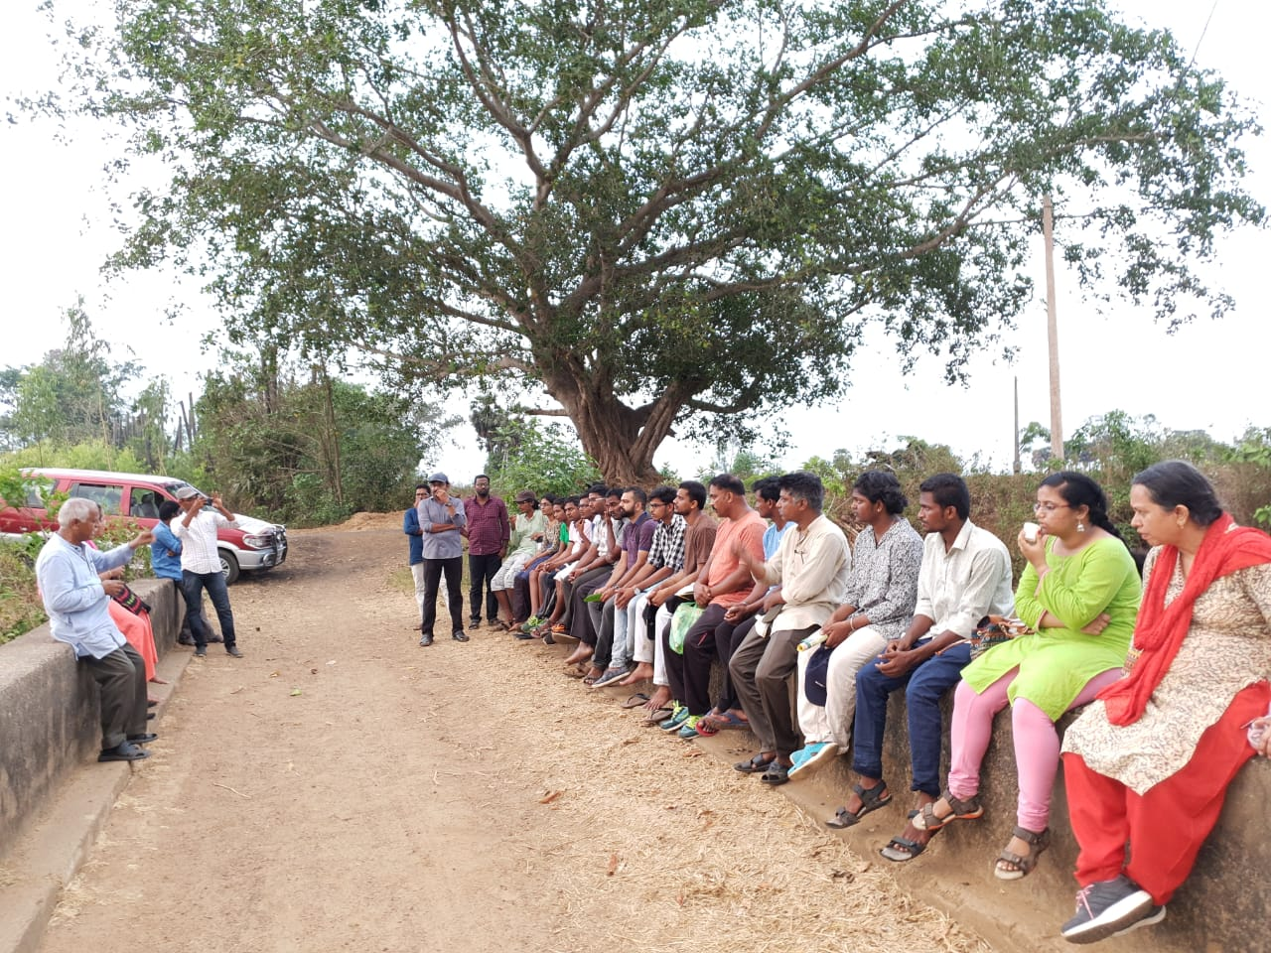
Explaining the success stories of gross root innovators of Pallesrujana by Sir

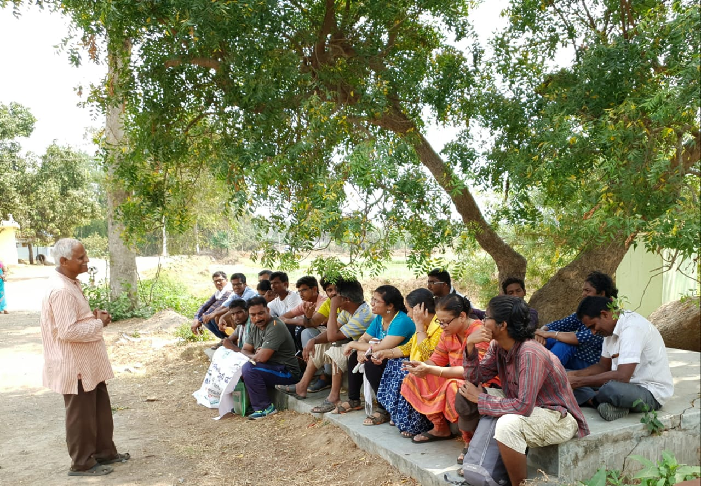
Brainstorming session during yatra

